David Hirst

David Hirst is one of the few English organists to have fully integrated into the French organ world. He works as titular organist of the 12th-century Collegiate Church of Notre-Dame in Mantes-la-Jolie, near Paris, where he presides over the 1897 Merklin organ and the new Cogez organ. He is Artistic Director of the city's International Organ Festival which features world-renowned performers such as Olivier Latry, Philippe Lefebvre, Jean Guillou, Daniel Roth and David Briggs.

As a recitalist David performs regularly across the world. Recent appearances include festivals at Chartres, Versailles and Antwerp Cathedrals, St Augustin's in Paris, the Laurenskerk in Rotterdam, and venues in the UK, Germany and Switzerland. As well as the festival in Mantes, he performs regularly at Marie-Claire Alain's previous church in Saint-Germain-en-Laye.

David holds a master's degree in music from Cambridge University and a postgraduate diploma with distinction in organ performance from the Royal Academy of Music in London. His teachers have included Nicolas Kynaston, Thomas Trotter and Lionel Rogg.

Previous organist appointments include Emmanuel College (Cambridge University), St Germain du Chesnay (Versailles) and St Martin-in-the-Fields, the royal parish church in London.

David has played 30 BBC broadcasts. Among his recordings, he has recently released the second CD of the Mantes-la-Jolie organs with the Priory label.
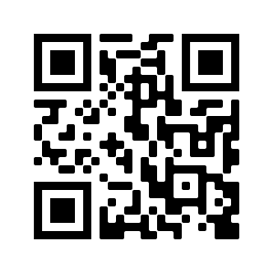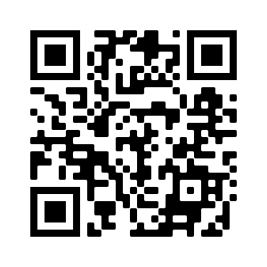
www.davidhirst.org
YouTube : https://youtu.be/DBkCgkxjq_o

